Dataflow:

Source:

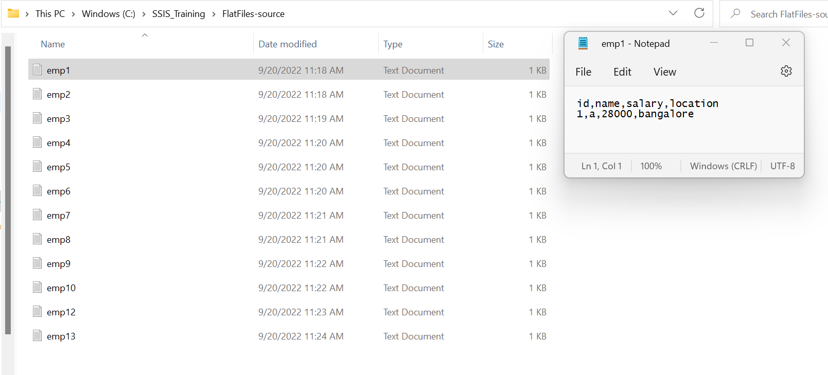

Destination:

